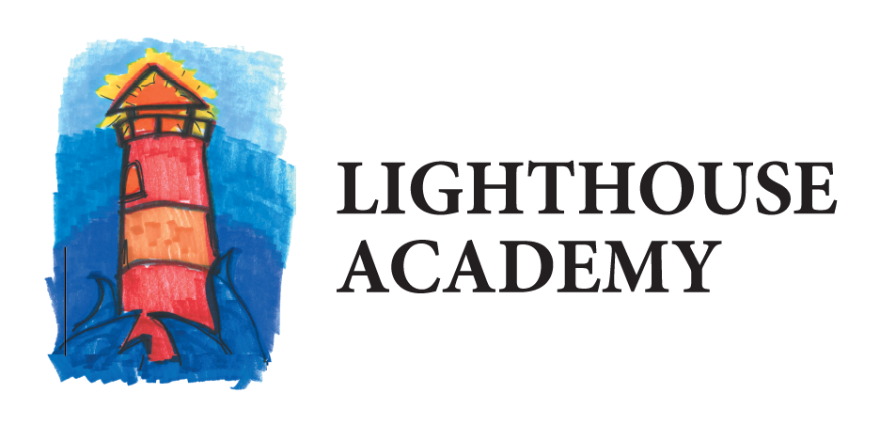
April 11, 2019

Dear Community Member;

Lighthouse Academy is pleased to tell you about another successful school year we are having in 2018-2019 in this Annual Education Report (AER).

In the past ten years since Lighthouse Academy opened its doors as a Strict Discipline Academy, it has enrolled students in grades 6-12 from the community until it reached its enrollment cap, at which point, if there was not an opening at the grade level needed by the students, they were put on a waiting list and a lottery to fill any open slots occurred from this list. Equal access for all on the waiting list was given except where they may have been a sibling of a student. In this case only, this student was given priority. In addition, Lighthouse Academy began to serve resident students at Wedgwood Christian services in the 2009-2010 school year, serving 1-12 grades. Subsequently, in the 2012-2013 school year, Lighthouse Academy began serving St. John’s Home residents, Waalkes Juvenile Detention Center students, The Haven residents, and unaccompanied minor refugee students and the Kent Fields and Day Treatment program of the Kent County Juvenile Court in a new North campus community building. In the current 2016-2017 school year, Lighthouse Academy-The Haven was closed by the end of October 2016 due to the facility closing. In addition, In the Fall of 2016, the district became the educational provider for the Kent County Correctional Facility (The school program is called, Lighthouse Academy-The Pier) and Eagle Village.

Lighthouse Academy achieved AYP in many areas and successfully implemented improvement plans to address three areas: raising the math and reading achievement through extra math and reading skills practicing in seminar class; at least 95% of our students taking the high sakes state testing every year; and higher graduation rates by tracking where students attend school after leaving Lighthouse Academy, especially in our residential program class rooms. We continue to work with the families of our students to address these goals so that all areas measured through AYP will be at or exceeding expectations by the end of each school year.

In addition, Lighthouse Academy continuously reviews its curriculum through its building and district Professional Learning Communities. Our school is accredited by Advanc-Ed and has will complete the re-accreditation process to continue this accredited status Spring of 2019. All curriculum are aligned to the Common Core.

We would also like to share some of the many highlights of achievements and successes of students at Lighthouse Academy over the past ten years since it opened as a Strict Discipline Academy charter school in September 2008. In our value-added goal areas, Lighthouse Academy has achieved the following results:

- Students receiving a score below grade level in Scantron/NWEA MAP district test results received remediation assistance through a course and/or tutoring.
- LA has met or exceeded its charter contract goals each year of at least 60% of students having significant growth in reading and math.
- LA students participated in job skill and career exploration activities as indicated in their educational development plan generated by Career Cruising results. Dozens of students have successfully completed a paid internship with are business partners through the WIOA program and Employment Training Programs operated in partnership with Wedgwood Christian Services.
- 100% of LA graduates left with a transition plan to continue their education, obtain a job, and/or enlist in the military.
- 95% of all students increased their pro-social skills through weekly life skills groups, service learning projects, and their relationships with LA staff and their advisor.
- 100% of all LA parents reported that they feel included in their child’s education and planning.

Other accomplishments are our continued emphasis on college and career planning with Lighthouse Academy students. In addition, each year some students have been dually enrolled in college courses during their senior year. Lastly, the percentage of parents who connect regularly with the school in face-to-face or phone meetings and/or through our parent webpage has continued to improve each school year.

The following link to the mischooldata.org web site contains Lighthouse Academy’s district state testing results, teacher qualifications, NAEP, and district school index: http://bit.ly/2IugoGT.

If you have any questions about this report, you may address them with Heidi Cate, Superintendent by calling 616-977-4917. The AER is available at our website at www.lighthouse academyschool.org or you may review it by asking at the Integrity Education Services’ Main Office at 3300 36th Street SE Grand Rapids, MI 49512 where a copy is kept.

Sincerely;

Heidi Cate

