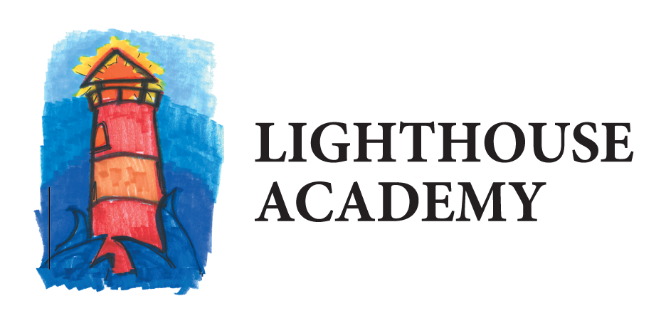
Waalkes
1501 Cedar St. NE
Grand Rapids, MI 49503

2/26/2019

Dear Parents and Community Members:

We are pleased to present you with the Annual Education Report (AER) which provides key information on the 2017-18 educational progress for the Lighthouse Academy Waalkes Program. The AER addresses the complex reporting information required by federal and state laws. The school’s report contains information about student assessment, accountability, and teacher quality. If you have any questions about the AER, please contact Lucas Yax, Principal, for assistance.

The AER is available for you to review electronically by visiting the following web site http://bit.ly/2VW8rOp or you may review a copy in the main office at your child’s school.

For the 2017-18 school year, schools were identified using definitions and labels as required in the Every Student Succeeds Act (ESSA). A Targeted Support and Improvement (TSI) school is one that has at least one underperforming student subgroup. An Additional Targeted Support (ATS) school is one that has three or more underperforming student subgroups. A Comprehensive Support and Improvement (CSI) school is one whose performance is in the lowest 5% of all schools in the state or has a graduation rate at or below 67%. Some schools are not identified with any of these labels. In these cases, no label is given.

Our school was identified as a Comprehensive Support and Improvement School
Lighthouse Academy Waalkes has faced multiple challenges over the school year. We continue to serve students who are with our program short term due to the programing of the facility. The students who are residing in the Waalkes facility also usually come with heavy trauma from their past, which makes for another barrier in regards to breakthrough in learning. Lighthouse Waalkes also continues to struggle with funding changes year to year due to ever changing enrollment numbers which impacts our ability to meet our variety of student needs. The average length of stay at the Waalkes facility is around 18 days and that has a high impact on our ability to have students take standardized assessments which would help with gauging individual academic needs. The key initiatives that are being undertaken at Lighthouse Waalkes that would bridge some of these gaps and help accelerate student achievement and close gaps would be the implementation of the MTSS/PBIS throughout the facility. The use of this program will assist with student’s level of comfort and effort put into the school as they are not accustomed to success in the educational setting. Lighthouse Leadership continues to analyze data and adjust programing as needed, within budgeting cost, to focus on student achievement. Finally, Lighthouse continues to look at the objectives in comparison to state standards in regards to monitoring student progress in the school due to the short average of stay with the facility. Best practices are continually looked into as to how to make the greatest impact in the short amount of time Lighthouse Waalkes has to work with the students.

State law requires that we also report additional information.

- Our enrollment comes from a referral process of Kent County Juvenile Court. Our students must reside at the Waalkes Juvenile Detention Center and meet the enrollment requirements
- We are currently in year three of our school improvement plan. At this time our plan remains constant with the past and remains on course with where it has been in the past with some minor additions. Our core goals remain the same in regards to focus on having students improve math and reading scores and gain credit in high school credit by offering a holistic educational experience.
- Lighthouse Waalkes is a school located in the facility of the Kent County Juvenile Detention Center. The facility is meant to house youth in Kent County in order for them to remain safe and secure when they are unable to do so in society. The school provides full time education for all for the students at the Waalkes facility as school is a requirement and not an option. Lighthouse Waalkes is focused on students meeting objectives which align with state standards as well as puts a serious concentration on credit recovery. Normal Special Ed services are also provided as needed and able within the guidelines of meeting the safety rules and regulations of the KCJDC facility.
- Our core curriculum meets the minimum state requirements for high school graduation. A copy of our courses is offered in our handbook which is given at enrollment or can be requested at the school office. The annual education report is also available through our website or a hard copy is in our school office
- Lighthouse Waalkes uses standardized testing for students to determine where they are scoring in comparison to the state average. Using the data from the SAT, MSTEP, and WorkKeys tests as well as the NWEA Map tests for students who are coming from or returning to a Lighthouse site. In all categories the Lighthouse Waalkes students fall below the state average. The data is periodically reviewed in order to make necessary changes to the program in order to improve student achievement.
- We hold parent teacher conferences at parent request or community partner request. Our school is in constant contact with case workers and court workers, therefore all students participate in a form or parent teacher conferences. In addition progress reports are sent out to P.O.’s on a normal basis as well as meetings to review individual learning plans which have been specially put together for clients.
- Lighthouse Academy Waalkes is a credit recovery institution and does not offer college credit for its high school classes, we also do not offer AP courses as our 100% of our students are behind in their current coursework. After staying two or more years with us many students are eligible for dual enrollment but those students have chosen to focus solely on their high school diploma and mastering those classes instead of dual enrolling

In conclusion, Lighthouse Academy continues to expand and serve more youth each year. Lighthouse has recently added two more sites which are in the implementation stages this year. The Lighthouse programs focus continues to highlight students that are in need of a non-traditional educational placement. We find that our students who choose to stay with one of the Lighthouse Programs are able to obtain their high school diploma and choose to be productive citizens. The students who Lighthouse serves are truly unique and deserve advocates to come to their aid and provide a quality education. The Lighthouse students are capable and able to achieve at the highest level! Let’s continue to work hard to help our students achieve their goals!

Sincerely,

Lucas Yax
Principal
Lighthouse Academy Waalkes

