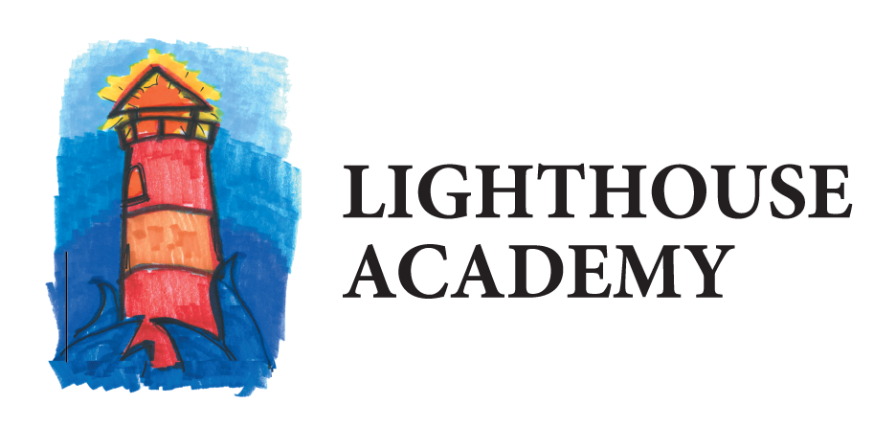
The Pier
701 Ball Ave. NE
Grand Rapids, MI 49503

2/26/2019

Dear Parents and Community Members:

We are pleased to present you with the Annual Education Report (AER) which provides key information on the 2017-18 educational progress for the Lighthouse Academy Pier Program. The AER addresses the complex reporting information required by federal and state laws. The school’s report contains information about student assessment, accountability, and teacher quality. If you have any questions about the AER, please contact Lucas Yax, Principal, for assistance.

The AER is available for you to review electronically by visiting the following web site http://bit.ly/2VS6RNj or you may review a copy in the main office at your child’s school.

For the 2017-18 school year, schools were identified using definitions and labels as required in the Every Student Succeeds Act (ESSA). A Targeted Support and Improvement (TSI) school is one that has at least one underperforming student subgroup. An Additional Targeted Support (ATS) school is one that has three or more underperforming student subgroups. A Comprehensive Support and Improvement (CSI) school is one whose performance is in the lowest 5% of all schools in the state or has a graduation rate at or below 67%. Some schools are not identified with any of these labels. In these cases, no label is given.

Our school was identified as a Comprehensive Support and Improvement School
Lighthouse Academy the Pier has faced multiple challenges over the school year. We continue to serve students who are with our program short term due to the programing of the facility. The students who are residing in the Pier program also usually come with heavy trauma from their past, which makes for another barrier in regards to breakthrough in learning. Lighthouse the Pier seems to struggle with consistent attendance as the students in the adult jail are not required to attend and the school is limited in how we can encourage students to attend other than for the simple reason to receive an education. The average length of stay at the Pier facility is around 25 days and students rarely are able to continue education upon leaving the program due to age restrictions. The length of stay and inability to transfer to another Lighthouse Program has a high impact on our ability to have students take standardized assessments which would help with gauging individual academic needs and setting student up for continued success. The key initiatives that are being undertaken at Lighthouse the Pier that would bridge some of these gaps and help accelerate student achievement and close gaps would be the implementation of the MTSS/PBIS throughout the facility although this is limited due to program restrictions. The use of this program will assist with student’s level of comfort and effort put into the school as they are not accustomed to success in the educational setting. Lighthouse the Pier also has taken the model of the Waalkes program and monitors and marks student objectives in comparison to state standards in regards to monitoring student progress in the school due to the short average of stay with the facility. Best practices are continually looked into as to how to make the greatest impact in the short amount of time Lighthouse the Pier has to work with the students.

State law requires that we also report additional information.
- Our enrollment comes from a referral process of Kent County Correctional Facility. Our students must reside at the KCCF and meet the enrollment requirements
- We are currently in year one of our school improvement plan. At this time our plan is in the implementation stages and has been a mirror of other successful locked down facility school programs within Lighthouse. Our core goals are to focus on having students improve math and reading scores and gain credit in high school credit by offering a holistic educational experience.
- Lighthouse the Pier is a school located within the Kent County Correctional Facility. The age groups served are normally between 17-22 however on occasion it is possible for a juvenile to be placed in the jail and require educational services. The school provides full time education for two units and part time education for three units (Based on programing and safety issues not all units are able to receive full time schooling). Lighthouse the Pier focused on students meeting objectives which align with state standards as well as puts a serious concentration on credit recover as 100 percent of the students served at this time have come to the facility behind on credits. Normal Special Ed services are also provided as needed and able within the guidelines of meeting the safety rules and regulations of the Kent County Correctional Facility.
- Our core curriculum meets the minimum state requirements for high school graduation. A copy of our courses is offered in our handbook which is given at enrollment or can be requested at the school office. The annual education report is also available through our website or a hard copy is in our school office. We hold parent teacher conferences at parent request or community partner request. The students in the Pier facility are normally ranging from 18-22 years of age.
- Lighthouse Pier uses standardized testing for students to determine where they are scoring in comparison to the state average. Using the data from the SAT, MSTEP, and WorkKeys tests as well as the NWEA Map tests for students who are coming from or returning to a Lighthouse site. In all categories the Lighthouse Pier students fall below the state average. The data is periodically reviewed in order to make necessary changes to the program in order to improve student achievement.
- We hold parent teacher conferences at parent request or community partner request. The students in the Pier facility are normally ranging from 18-22. The students are able to meet about grades and discuss issues as they are independent of parents. Our school is in constant contact with court workers and community partners, therefore all students participate in a form or parent teacher conferences. In addition progress reports are sent out to P.O.’s on a normal bases as well as meetings to review individual learning plans which have been specially put together for clients.
- Lighthouse Academy is a credit recovery institution and does not offer college credit for its high school classes, we also do not offer AP courses as our 100% of our students are behind in their current coursework. After staying two or more years with us many students are eligible for dual enrollment but those students usually choose to concentrate their efforts solely on their high school diploma instead of dual enrolling

In conclusion, Lighthouse Academy continues to expand and serve more youth each year. Lighthouse has recently added two more sites which are in the implementation stages this year. The Lighthouse programs focus continues to highlight students that are in need of a non-traditional educational placement. We find that our students who choose to stay with one of the Lighthouse Programs are able to obtain their high school diploma and choose to be productive citizens. The students who Lighthouse serves are truly unique and deserve advocates to come to their aid and provide a quality education. The Lighthouse students are capable and able to achieve at the highest level! Let’s continue to work hard to help our students achieve their goals!

Sincerely,

Lucas Yax
Principal
Lighthouse Academy Waalkes

